**SierraPay Project Documentation**

**1. Project Overview**

**Objective:** To develop a FinTech mobile application prototype called *SierraPay* that digitizes payment systems in Sierra Leone. It allows users to register, link bank/mobile accounts, send and receive payments, and track transactions across mobile networks regardless of SIM type.

**2. Functional Requirements**

* User Registration and Login
* Two-Factor Authentication (OTP)
* Link Bank/OrangeMoney Account
* Make Payments to Vendors or Users
* View Transaction History
* Send and Receive Money
* Wallet Balance Management
* Notification System (Email/SMS)
* Feedback and Ratings
* Admin Dashboard

**3. Non-Functional Requirements**

* Response Time < 2 seconds
* Data Encryption (End-to-End)
* 99.9% Uptime
* Scalability to 100M+ Users
* Fault Tolerance and Recovery < 5 min
* Secure Session Management

**4. Requirements Engineering Process**

* Simulated interviews, surveys, and observations of mobile users in Sierra Leone
* Use Case Diagram created
* User Stories written (GitHub Issue Format)
* Functional/Non-functional requirements clearly outlined

**5. System Modeling**

* **Use Case Diagram:** Visualizes interactions between users and core system functionalities

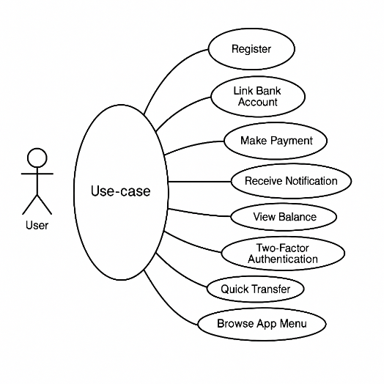

* **Class Diagram:** Detailed representation of system classes (User, Account, Wallet, Transaction, Notification, etc.)

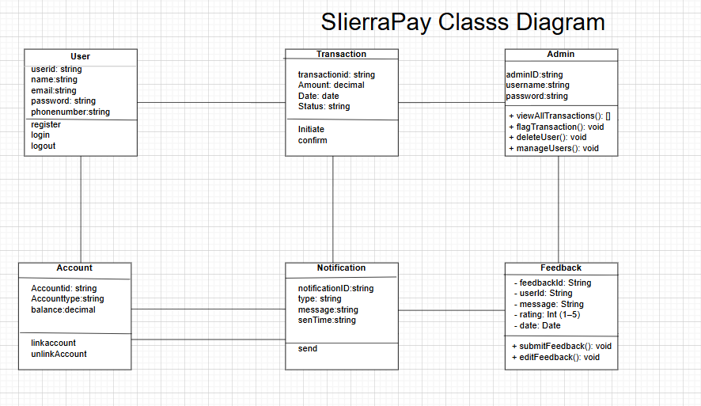

* **Sequence Diagram:** Describes the flow for “Make a Payment” from user to notification

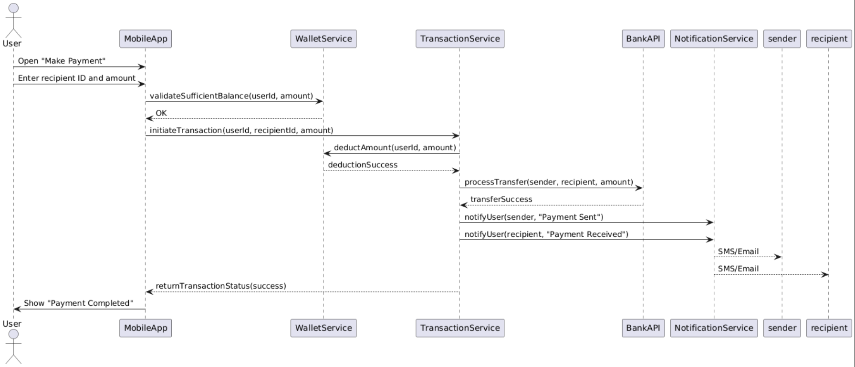

* **Activity Diagram:** Outlines the logical flow for payment processing and decision-making

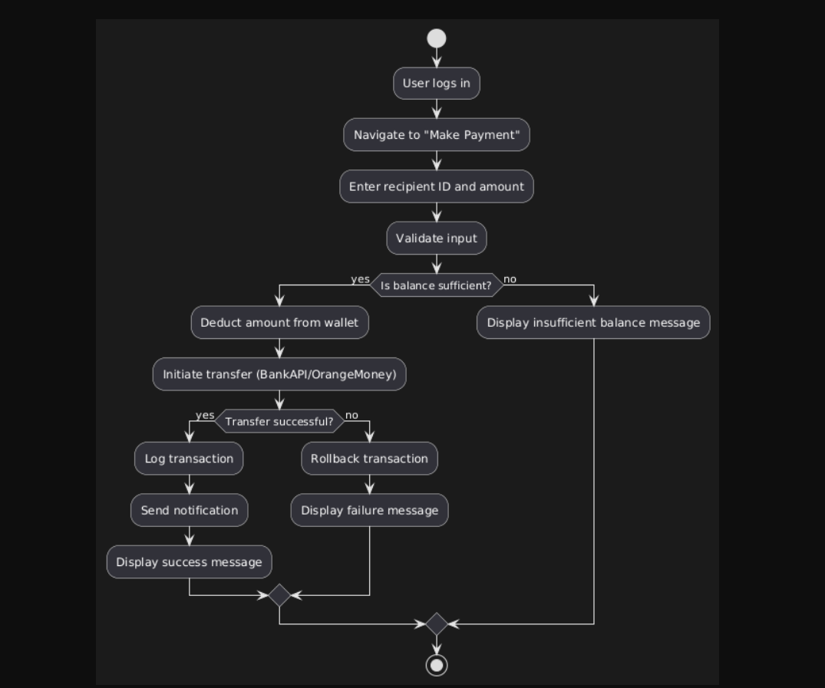

**6. Version Control (GitHub)**

* **Repository Created:** https://github.com/david-sawaneh/sierrapay
* **Branches Created:** user-registration, make-payment, send-money, view-transaction, link-bank-account, admin-panel
* **Pull Requests:** Merged feature branches into main
* **Issues:** Created for each user story (GitHub format)
* **Project Board:** Used GitHub Projects (Kanban) to track progress

**7. UI/UX Design**

* **Low-Fidelity Wireframes:** Created in Figma showing layout and flow

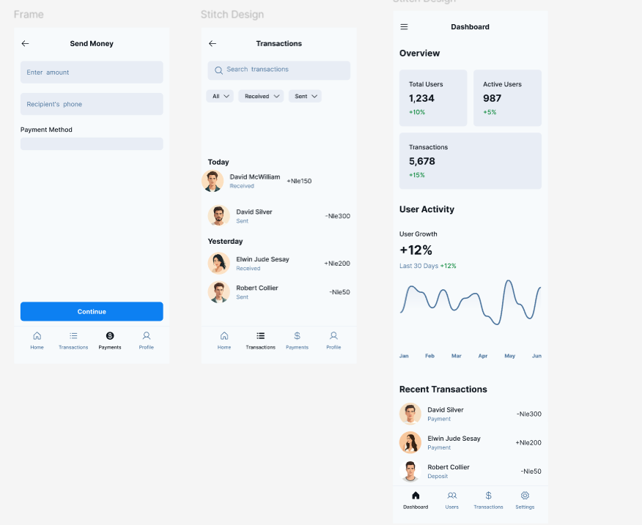

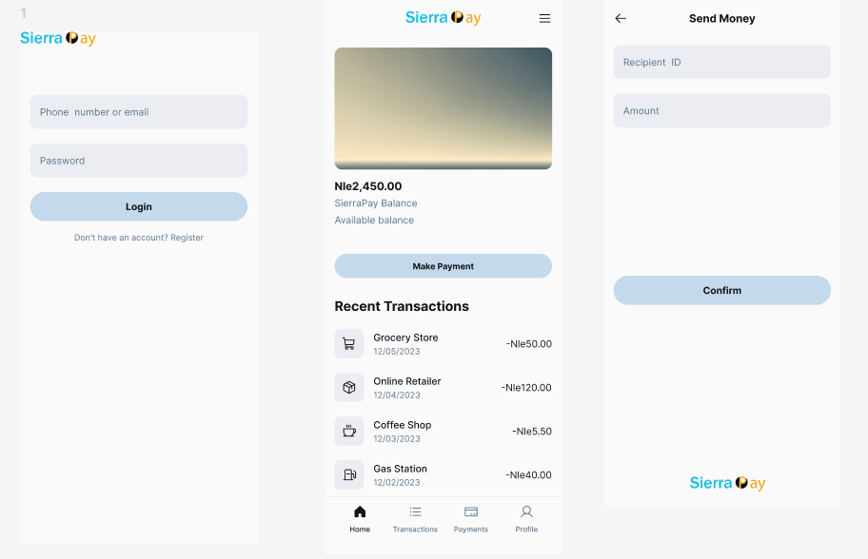

**High-Fidelity Prototypes:** Styled with real colors, icons, typography

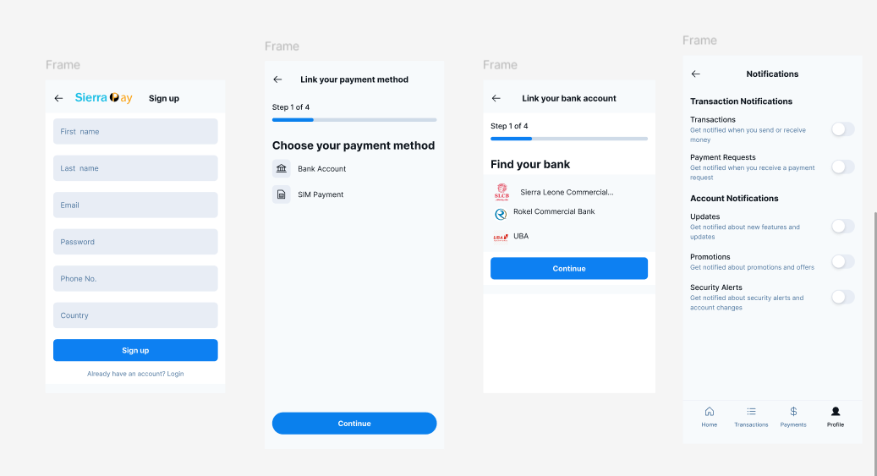

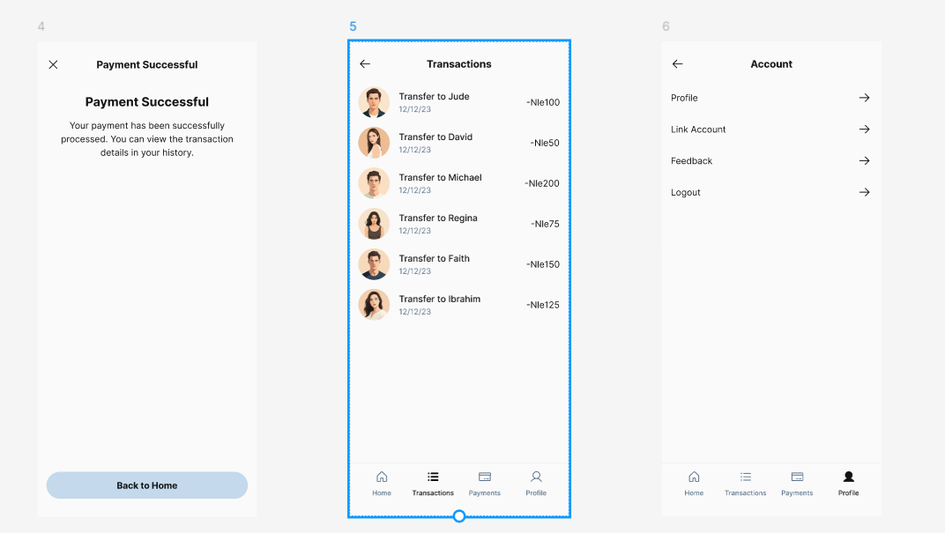

**8. Project Management**

* **Work Breakdown Structure:** Divided into requirements, modeling, development, design, and testing.

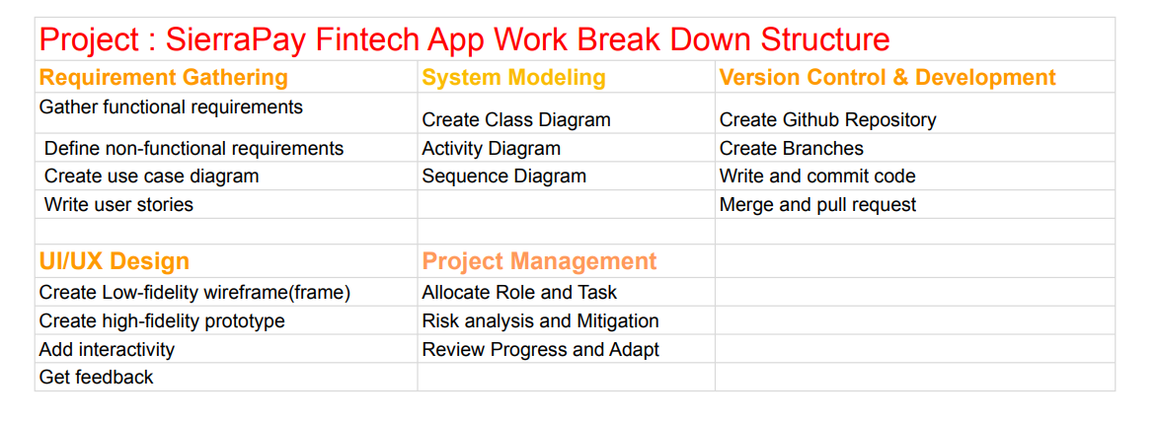

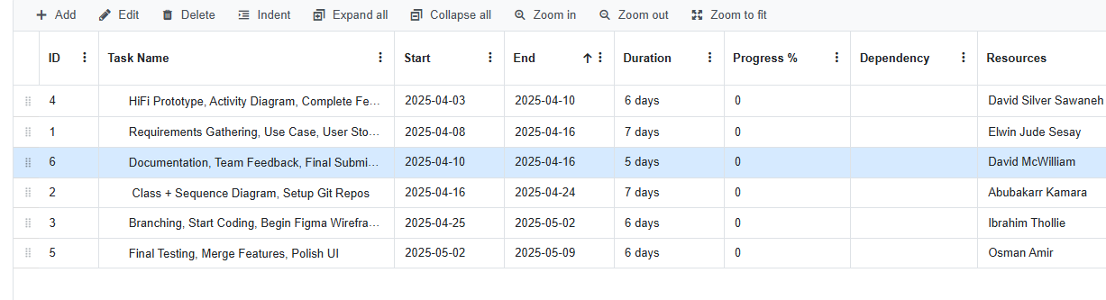**Gantt Chart:** 6-week timeline covering all phases

* **Roles Assigned:**
  + David – Team Lead & Backend Dev
  + 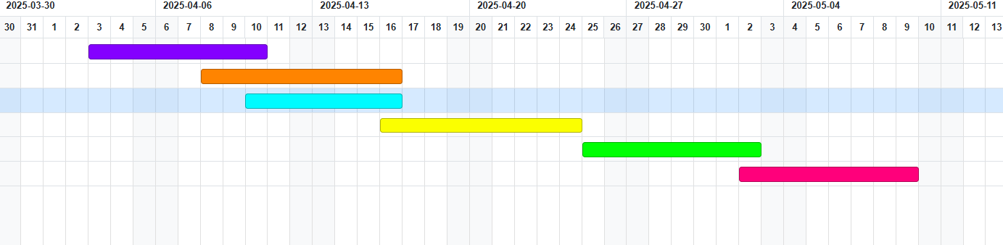Fatmata – UI/UX Designer
  + Ibrahim – Wallet & Transaction Logic
  + Mary – Frontend Developer
  + Abdul – QA Testing
  + Alusine – Documentation Lead
* **Risk Management:** Simulated members handled by branch/task assignment
* **Progress Tracking:** Weekly checkpoints, GitHub Issues, and board movement

**9. Tools Used**

* **GitHub** – Version control, issues, PRs, project tracking
* **Figma** – UI/UX wireframes and interactive prototypes
* **PlantUML** – Diagrams (class, sequence, activity)
* **Google Sheets** – Gantt Chart, task lists

**10. Conclusion**

SierraPay is a forward-thinking digital solution tailored to the Sierra Leonean economy. Through well-documented planning, modeling, design, and simulated team collaboration, the prototype reflects industry-level practices in software engineering.

This project showcases the entire SDLC from requirements to final prototype and offers a scalable foundation for real-world implementation.

**Appendices:**

* GitHub Repo Link
* Figma Prototype Link
* Diagrams (Class, Sequence, Activity)
* Gantt Chart Snapshot
* User Stories (Markdown or PDF Format)